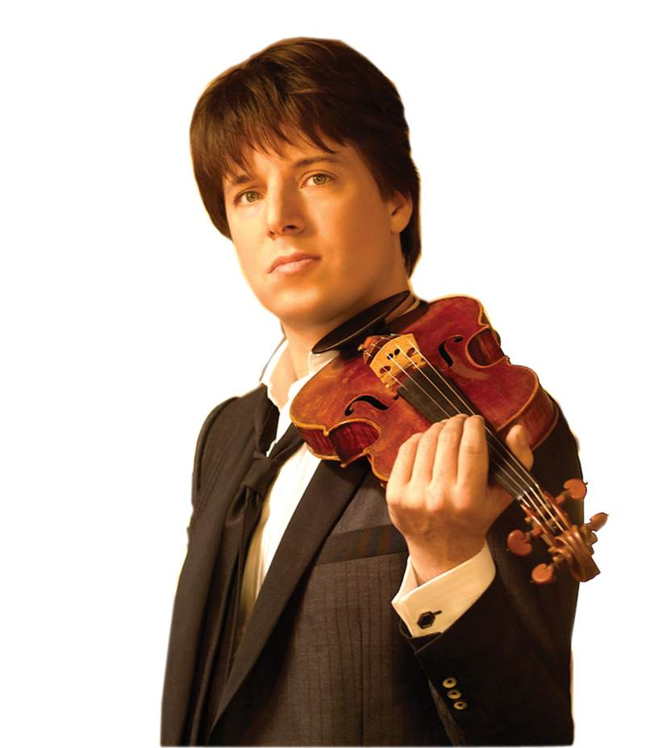A Violinist in the Metro

A Social and Philosophical Experiment

Question: What would occur if a famous violinist began playing in a busy metro station? How many people (out of 1,000 people) would recognize the quality, stop and spend some time listening to him (35, 50, 75...)? How much money would he make?

The following viral story, A Violinist in the Metro, describes what happened when acclaimed classical violinist Joshua Bell appeared incognito on a subway platform in Washington, D.C. one cold winter morning and played his heart out for tips. The viral text has been circulating since December 2008 and is a true story.
A man sat at a metro station in Washington D.C and started to play the violin; it was a cold January morning. He played six Bach pieces for about 45 minutes. During that time, since it was rush hour, it was calculated that thousands of people went through the station, most of them on their way to work.
Three minutes went by and a middle aged man noticed there was musician playing. He slowed his pace and stopped for a few seconds and then hurried up to meet his schedule.
A minute later, the violinist received his first dollar tip: a woman threw the money in the till and, without stopping, continued to walk.
A few minutes later, someone leaned against the wall to listen to him, but the man looked at his watch and started to walk again. Clearly, he was late for work.
The one who paid the most attention was a three-year-old boy. His mother tagged him along, hurried, but the kid stopped to look at the violinist. Finally, the mother pushed hard and the child continued to walk, turning his head all the time. This action was repeated by several other children. All the parents, without exception, forced them to move on.
In the 45 minutes the musician played, only six people stopped and stayed for a while. About 20 gave him money, but continued to walk their normal pace. He collected $32. When he finished playing and silence took over, no one noticed it. No one applauded, nor was there any recognition.
No one knew this, but the violinist was Joshua Bell, one of the best musicians in the world. He played one of the most intricate pieces ever written with a violin worth 3.5 million dollars.
Two days before his playing in the subway, Joshua Bell sold out at a theater in Boston and the seats averaged $100 each.
This is a real story. Joshua Bell playing incognito in the metro station was organized by the Washington Post as part of an social experiment about perception, taste, and the priorities of people.
The outlines were, in a commonplace environment at an inappropriate hour:
Do we perceive beauty?
Do we stop to appreciate it?
Do we recognize the talent in an unexpected context?
One of the possible conclusions from this experience could be that if we do not have a moment to stop and listen to one of the best musicians in the world playing the best music ever written, how many other things are we missing?

https://www.washingtonpost.com/lifestyle/magazine/pearls-before-breakfast-can-one-of-the-nations-great-musicians-cut-through-the-fog-of-a-dc-rush-hour-lets-find-out/2014/09/23/8a6d46da-4331-11e4-b47c-f5889e061e5f_story.html

https://www.youtube.com/watch?v=hnOPu0_YWhw

Facts:
- Joshua played for 45 minutes during rush hour in the metro station.
- Joshua was dressed in street clothes.
- The first donation came after three minutes. A woman gave Joshua one dollar.
- After six minutes one person stood to watch.
- 27 people in total gave money. He earned $32.
- 1070 people passed by without a glance.
- About three people were extremely impressed.
- One person recognized him and watched the rest of the show.
- A crowd never formed.

Answer the questions:
- Why do you think most people walked by?
- Do you think you would have passed by without thinking about it?
- Would you have put some money in the case? Why or why not?
- Do you and your friends appreciate classical music? Why or why not?
- What can be learned from this experiment?
- How do you think the woman who spoke to the musician felt after she left that day?
- How do you think Joshua Bell felt after doing this experiment?
- How do you think an average street performer would feel after seeing this video?
- After seeing this video, do you think you will pay more attention to street performers? Why or why not?

Afterthought
But then, in 2014...
Bell returned to the subway in September 2014, but this time his appearance was announced and it was a massive triumph – as the pictures below show – with thousands of attendees. After all those years and countless retellings of the story, finally, some recognition.

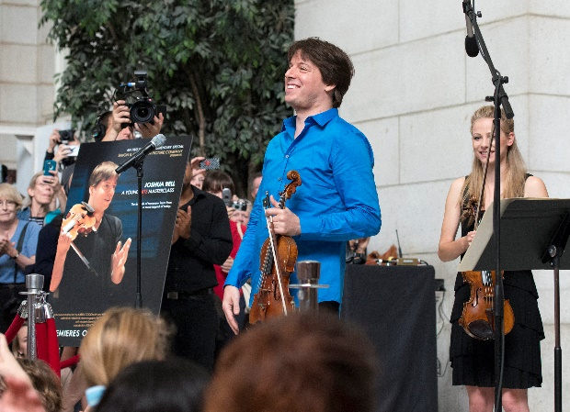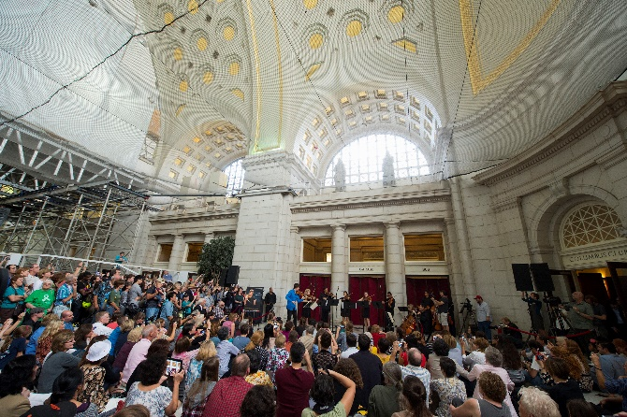
Bell's reaction after he finished his first movement of Bach? "Wow. That's more like it."
https://www.youtube.com/watch?v=BJhZ0J3bIYc

